Challenges – 13/10/2026
1.) Launch one aws ec2 and install jenkins.
Step -1 Create one AWS EC2 -Instance and try to connect with windows
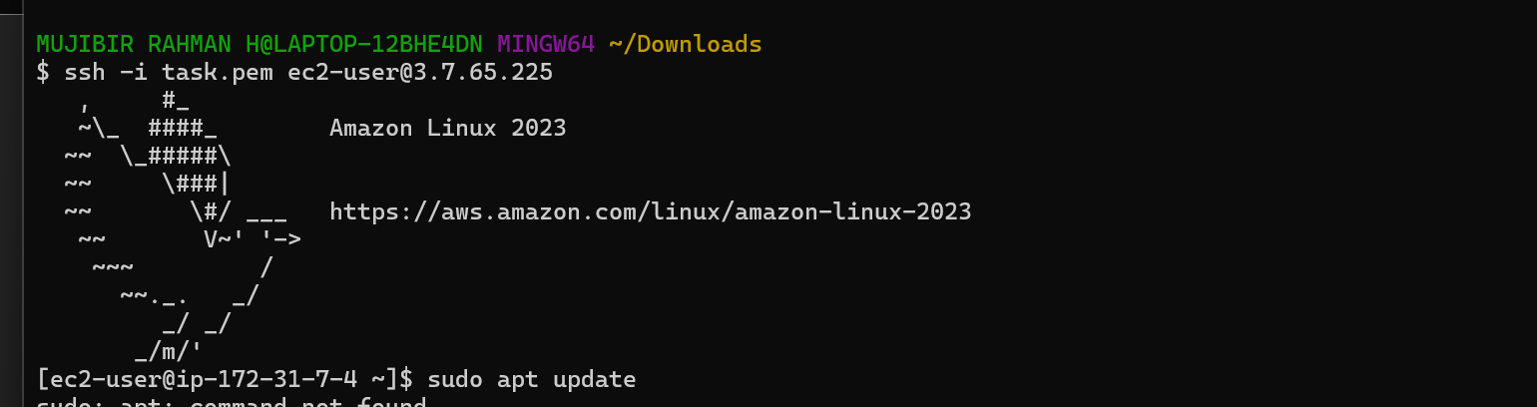
Step -2 Installing java 21 version in that EC2 – server using below commands :
sudo dnf install java-21-amazon-corretto -y
Checked the java version using this command- java -version
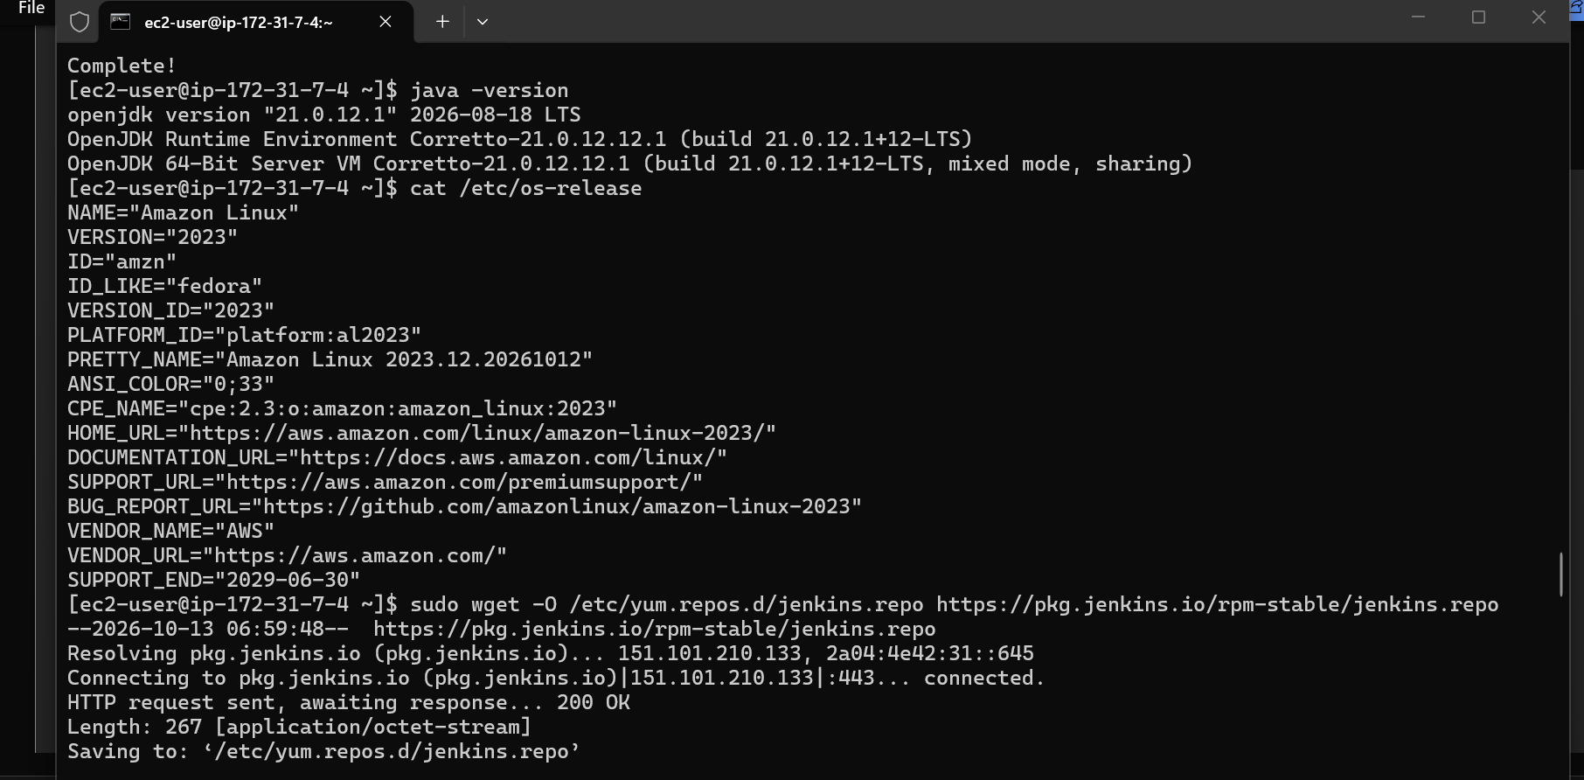
Step -3 Installing Jenkins
a.)Creating a Jenkins LTS repo ->
sudo wget -O /etc/yum.repos.d/jenkins.repo https://pkg.jenkins.io/rpm-stable/jenkins.repo
b.)Creating a Jenkins signing key ->
sudo rpm --import https://pkg.jenkins.io/rpm-stable/jenkins.io-2026.key
c.) Installing Jenkins –> sudo dnf install jenkins -y
d.) starting Jenkins -> sudo systemctl start Jenkins
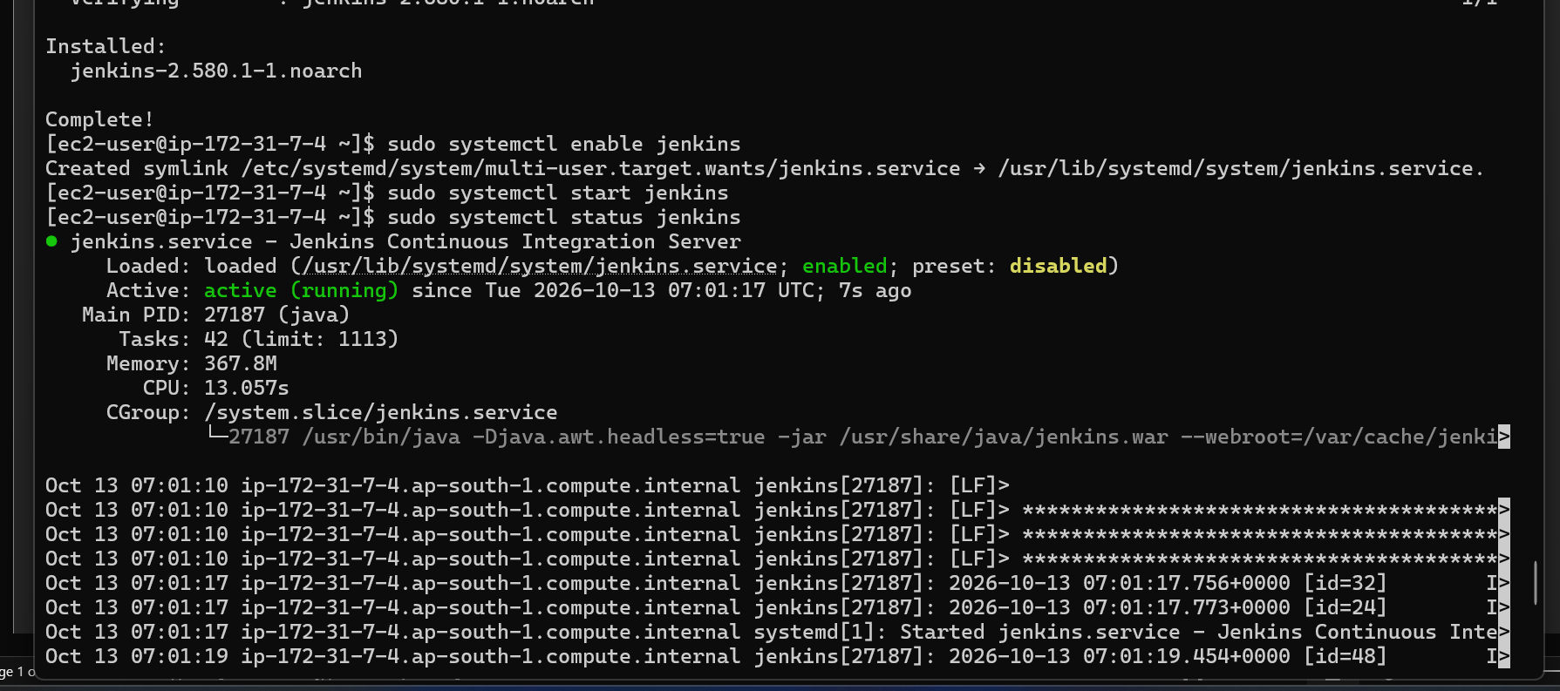
e.) checking ths status of Jenkins -> sudo systemctl start Jenkins
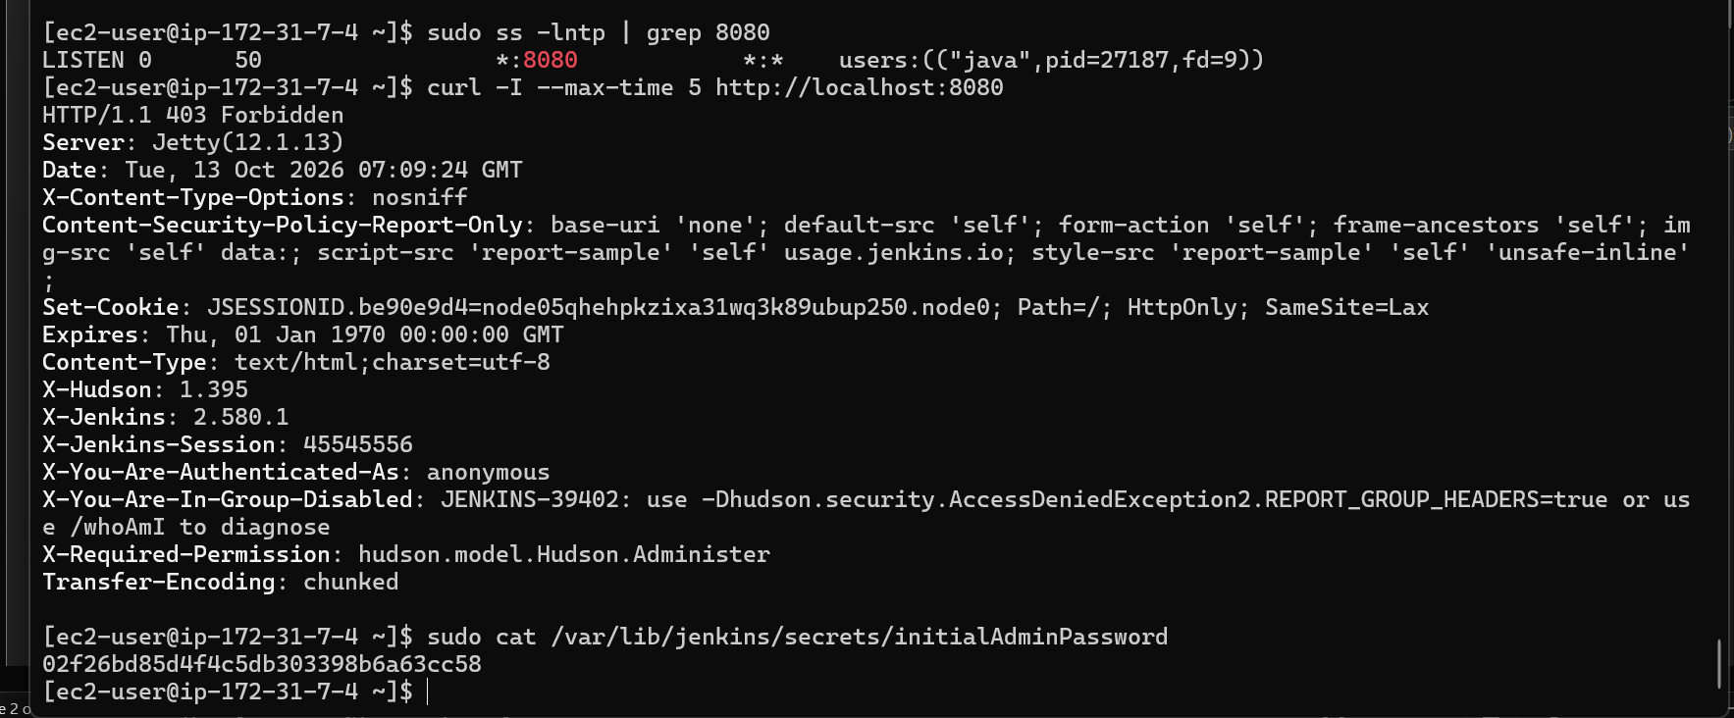
f.) Opened a chrome and hit a public Ip for that instance
g.) Able to see unlock your Jenkins
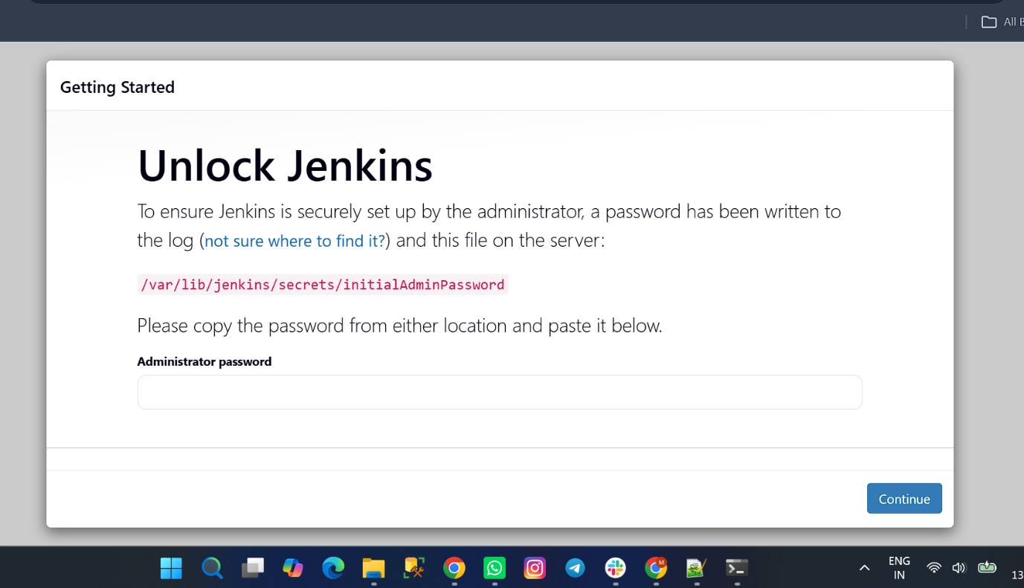
h.) After that, I got one administrator password using this command
sudo cat /var/lib/jenkins/secrets/initialAdminPassword
i.) Then I created my user account.
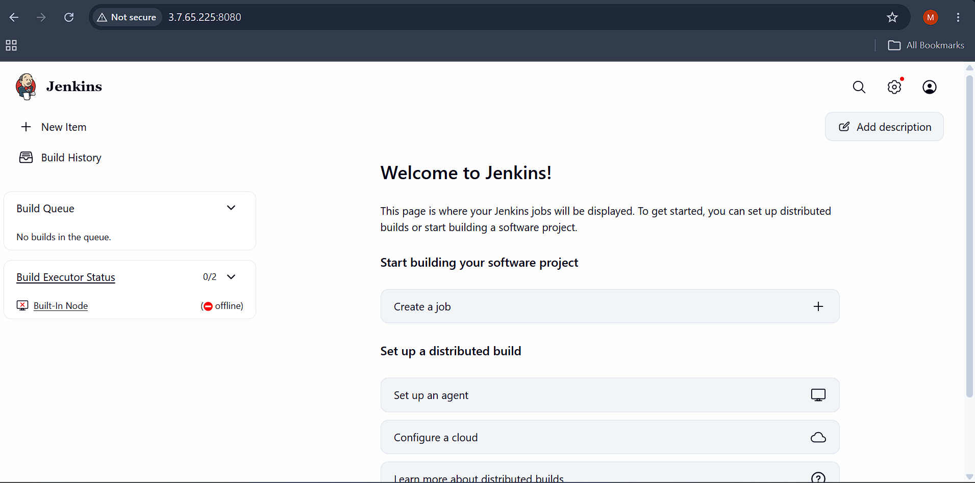
============================================================================
2.) Setup Apache Tomcat on Ubuntu Virtual Machine
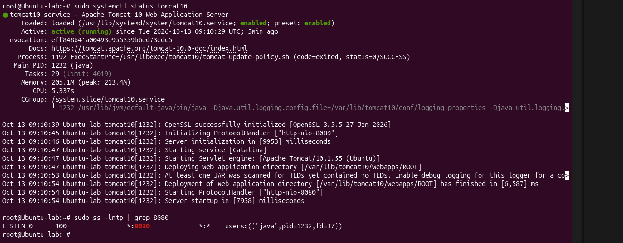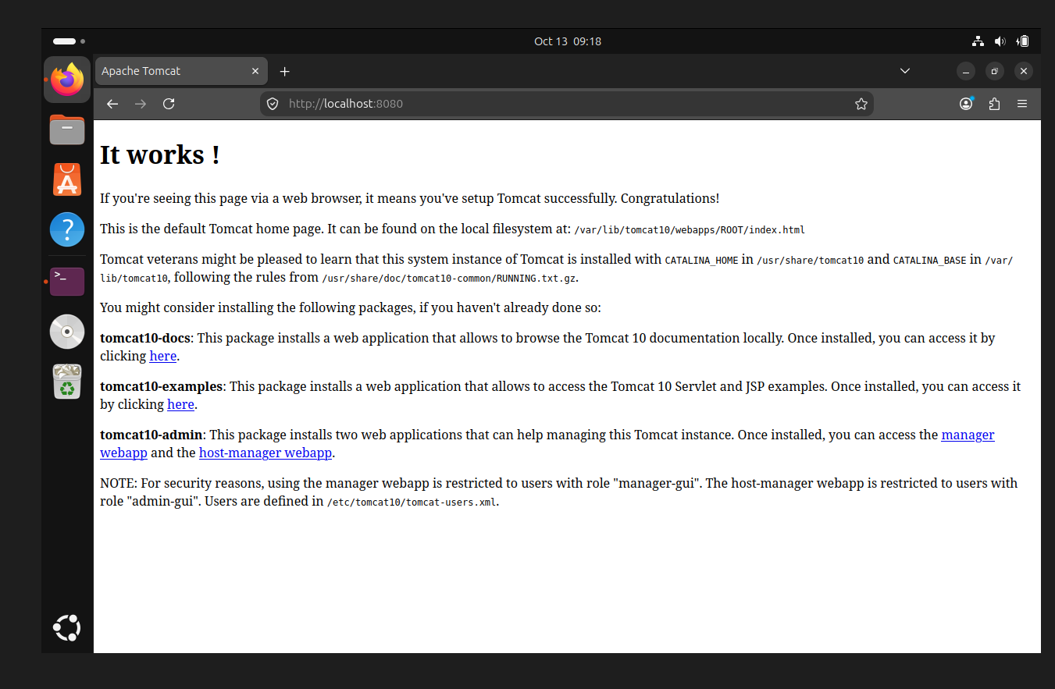
============================================================================
3.) Setup Docker Desktop on your local windows.
